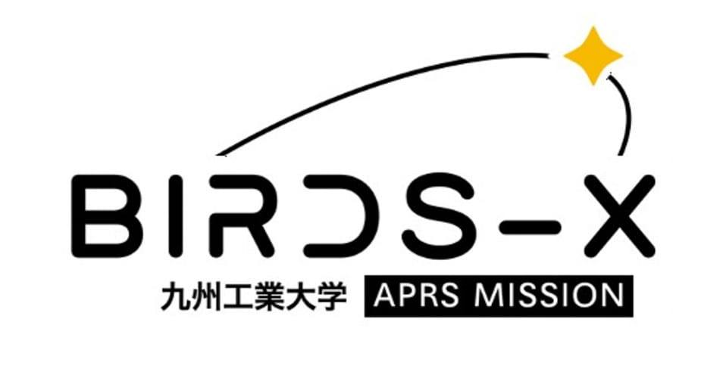
Consent for Open Sourcing
In this project, we will publish all the information about the satellite as open source. If you participate in BIRDS-X APRS Payload Design Competition, please check the box below, as an understanding that your documents will also be made open source.

☐ WE GIVE AUTHORIZATION FOR ALL DOCUMENTS REGARDING THE PAYLOAD COMPETITION TO BE MADE OPEN SOURCE

Name: ______________________________
Signature: ___________________________
Date: _______________________________

