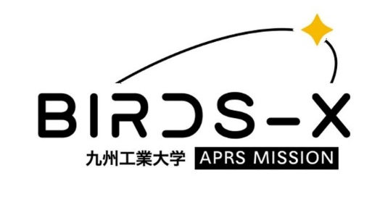
BIRDS-X Payload Competition Application Form Phase 1
Date of Application: 202X/MM/DD

1. Team information
Team name:
Organization:
Address:
City: State/Province:
Country: Zip code:
Phone number:
Email address:

Team members information
Official position | Full name | Nationality | Occupation and level
Example | Tasuku MATSUI | Japanese | Bachelor 3
Point of Contact
(Primary)
Point of Contact
(Secondary)
Member 1
Member 2
Member 3
Member 4
Member 5
Member 6
Member 7
Member 8

2. Motivation
Please write your motivation to join the competition.

2.1 Objective and expected outcomes
Please write your objective for doing the mission and what do you expect to achieve at the end of the competition.

3. Mission definition
Please write how you plan to develop and implement your payload design to participate in the competition.

3.1 Block diagram
Please put a block diagram of the payload you plan to develop.
(Add sensor if want to include one)

3.2 Concept of operation
Please describe the concept of operation for your payload.

4. Plan for budget
Please estimate the overall development cost and how do you plan to secure the fundings.

5.Plan for outreach
Please describe how you plan to spread awareness about your mission especially with amateur radio community.

6. Development schedule plan
Year / Month | Event
2023 / Feb. | Start to develop payload.

