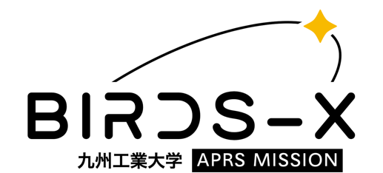
BIRDS-X Payload Competition Application Form Phase 1
Date of Application: 2023/MM/DD

1. Team information
Team name: BIRDS-X
Organization: Kyushu Institute of Technology
Address: 1-1 Sensui-cho, Tobata,
City: Kitakyushu State/Province: Fukuoka
Country: Japan Zip code: 804-8550
Phone number: (+81) 010-12340-5678
Email address: birds-x-project@kyutech-laseine.net

Team members information
Official position | Full name | Nationality | Occupation and level
Point of Contact  (Primary) | Jorge CASIR | Mexico | PhD 1
Point of Contact  (Secondary) | Merisa KOSIYAKUL | Thailand | Master 1
Member 1 | Guillaume BERSON | France | Master 1
Member 2 | Javier FERRER | Paraguay | Master 1
Member 3 | Tasuku MATSUI | Japan | Bachelor 3
Member 4 | Ei PHYU PHYU | Myanmar | Master 2
Member 5 | Sara AZIZ GHALAB | Egypt | PhD 1
Member 6 | Tharindu DAYARA THNA | Sri Lanka | Professional
Member 7 | Souta MIYAJIMA | Japan | Bachelor 3
Member 8 | Marco PANETTI | Italy | Master 1
Member 9 | Yudai ETSUNAGA | Japan | Master 1
Member 10 | Miyu INOUE | Japan | Bachelor 3

2. Motivation
Please write your motivation to join the competition.

2.1 Objective and expected outcomes
Please write your objective for doing the mission and what do you expect to achieve at the end of the competition.

3. Mission definition
Please write how you plan to develop and implement your payload design to participate in the competition.

This project aims to design and develop an APRS payload for a nanosatellite that can effectively store and forward APRS packets, and to participate in the APRS payload competition held by Kyutech.
Our team will use a systematic approach, such as the Systems Engineering process, to select feasible components, design and develop the payload, and perform tests and simulation tools to validate the payload's performance.
The project will start with the research and selection of appropriate sensors and a transceiver that meets the requirements for mass, volume, data transmission and power consumption.
After that we will design a prototype of the payload, including the sensor interface and data processing algorithms. Before sending the Engineering Model and the Flight Model to Kyutech we plan to do our own testing.

3.1 Block diagram
Please put a block diagram of the payload you plan to develop.
(Add sensor if want to include one)
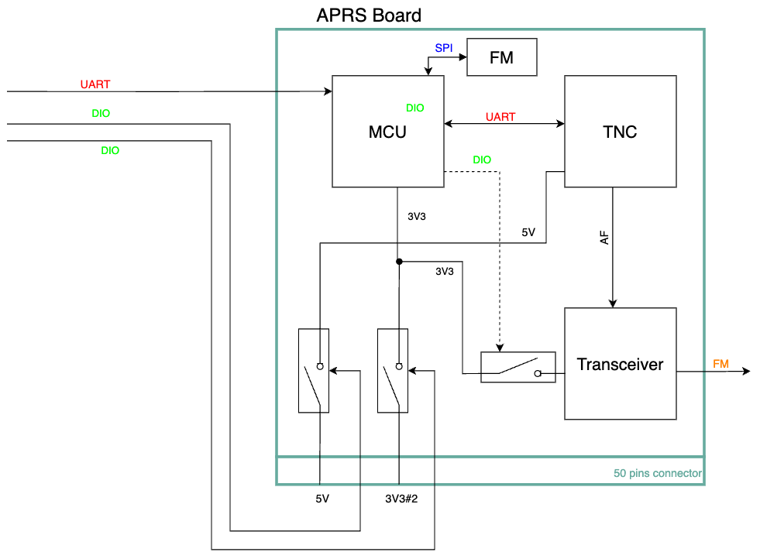
3.2 Concept of operation
Please describe the concept of operation for your payload.

The APRS payload is designed to work as an APRS repeater allowing communication in remote or inaccessible areas and, when needed, to store and forward APRS packets coming from ground stations.
APRS payload will receive power supply from the satellite power lines and will communicate with the mission MCU using the protocol and lines established on the ICD.
Once the payload is activated, our MCU activates the TNC. The MCU will send data containing the APRS beacon message to the TNC. TNC creates an AX.25 packet with the APRS beacon message to send it to the transceiver using an AFSK modulation signal. The signal arriving at the transceiver will be converted to RF signal and is transmitted through the antenna. This process will be repeated every 60 seconds.
After every beacon, the transceiver will be in reception mode so it can receive APRS packets incoming from ground terminal. Once a packet is received it will be decoded by the TNC, processed by the MCU and it will be sent back to the transceiver.
If the incoming packet is for store and forward purposes, the TNC will send the APRS packet to the MCU and will save it in the flash memory.

4. Plan for budget
Please estimate the overall development cost and how do you plan to secure the fundings.

In terms of budget, we plan to engage our university, government agencies and local amateur community for funding. We hope to engage with local suppliers in terms of sponsorship and discount, in order to reduce costs as far as procurement is concerned. We are considering also crowdfunding platforms like Kickstarter, as well as private companies or investors that may be interested in our project’s future developments. The project budget considering all the components (sensors, connectors, transceiver, PCB), the tools and the facilities needed is estimated to be around 1000 USD.

5.Plan for outreach
Please describe how you plan to spread awareness about your mission, especially with the amateur radio community.

We plan to raise awareness about APRS and amateur radio community by advertising our project on social media, LinkedIn, Facebook and open a YouTube channel to share constant updates and information on the mission. Meanwhile attending conferences related to amateur radio and nanosatellites to make connections and reach out to other organizations working in the same field. Collaborating with them will give us access to a wider audience and more resources.
We will organize public events such as workshops, presentations, and hands on demonstrations to educate the community especially students and generate interest in the mission.
We will reach out to local and national media outlets to get coverage for the mission and publish articles and press releases to keep the public informed.

6. Development schedule plan
Year / Month | Event
2023 / Jan | Selection of feasible components
2023 / Feb | Procurement of components
2023 / Mar | Bread board model designing and testing
2023 / Apr | Submit the documents for second phase
2023 / May | Start developing EM board
2023 / Jul | Finish functional test and communication test
2023 / Aug | Submission of EM board
2023 / Oct | FM board development
2023 / Nov | Finish functional test and communication test for FM board
2023 / Dec | Submission of FM board

